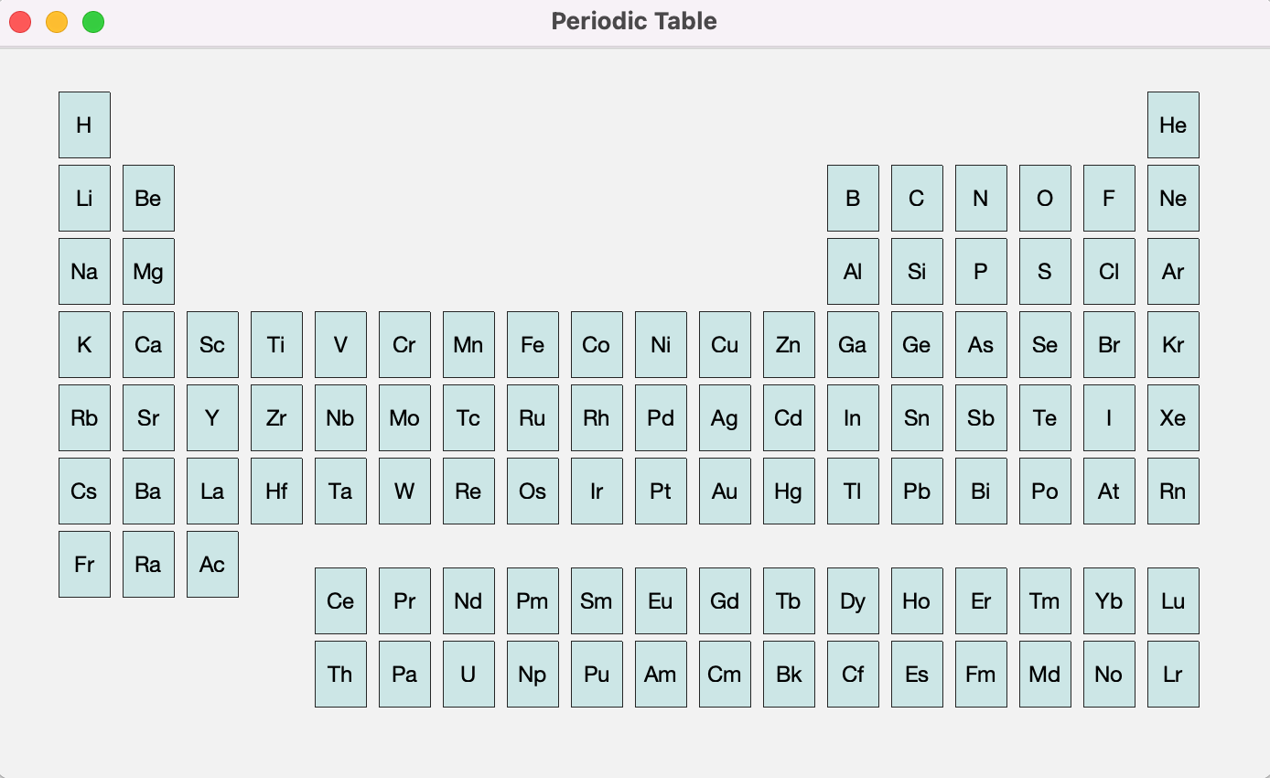

**After “Ir” was clicked:** 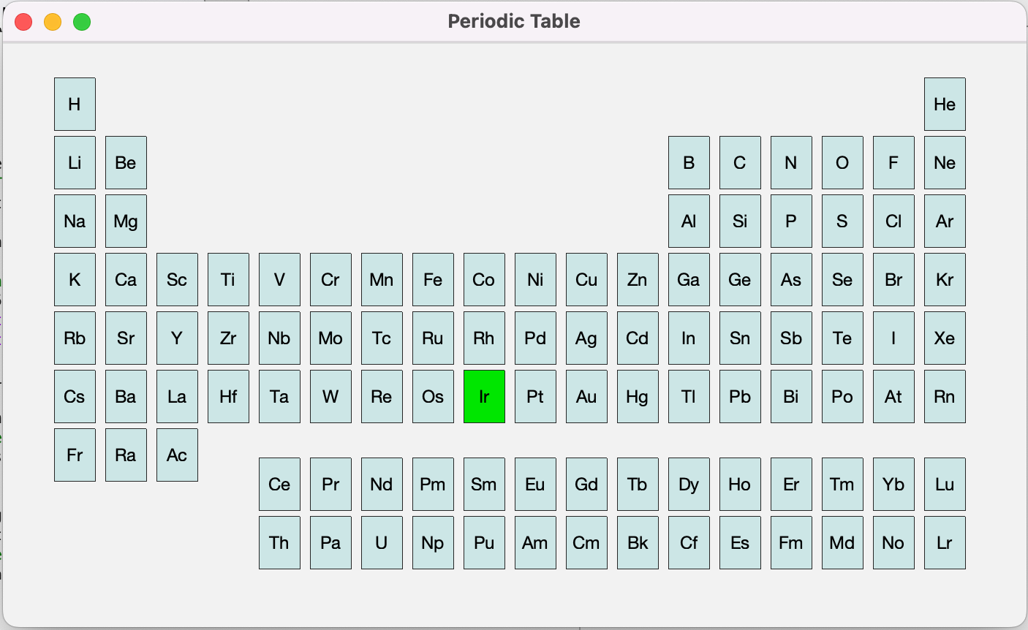

In the command window:

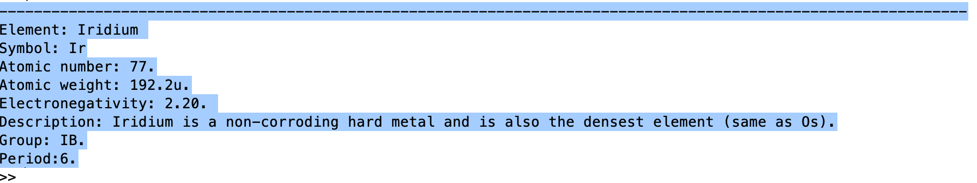

**After “Pm” was clicked:** 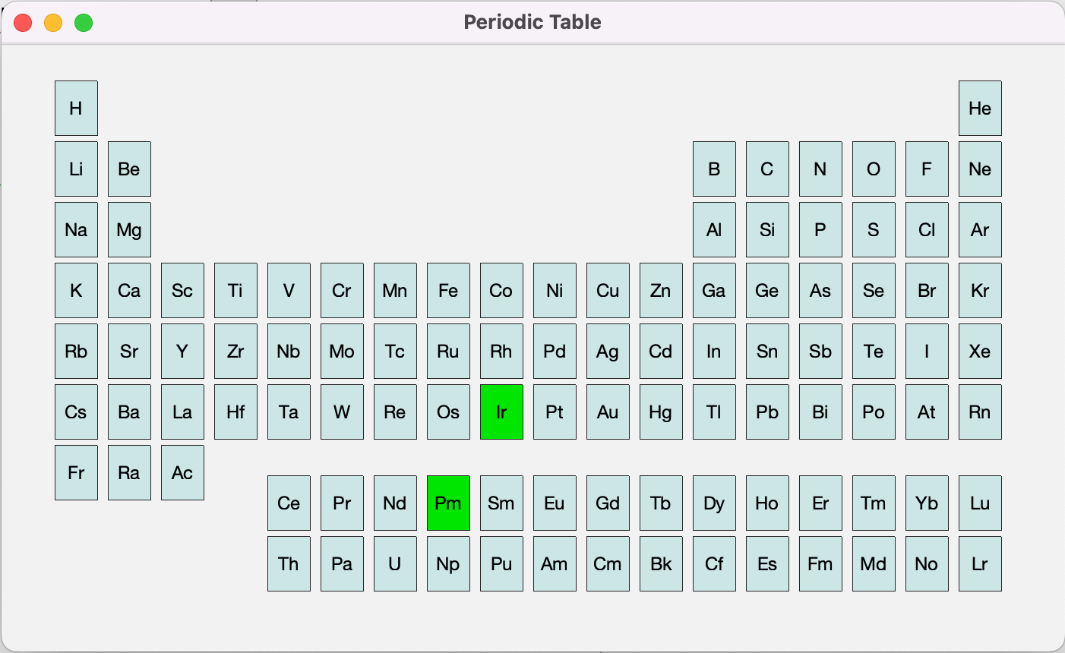

In the command window:

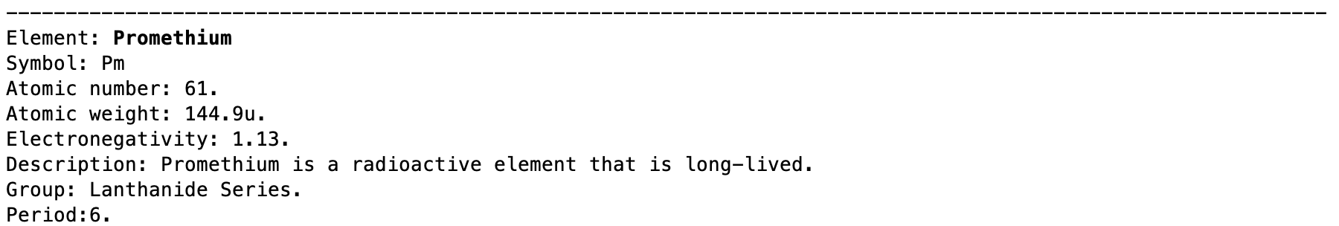

**After “Au” was clicked:**

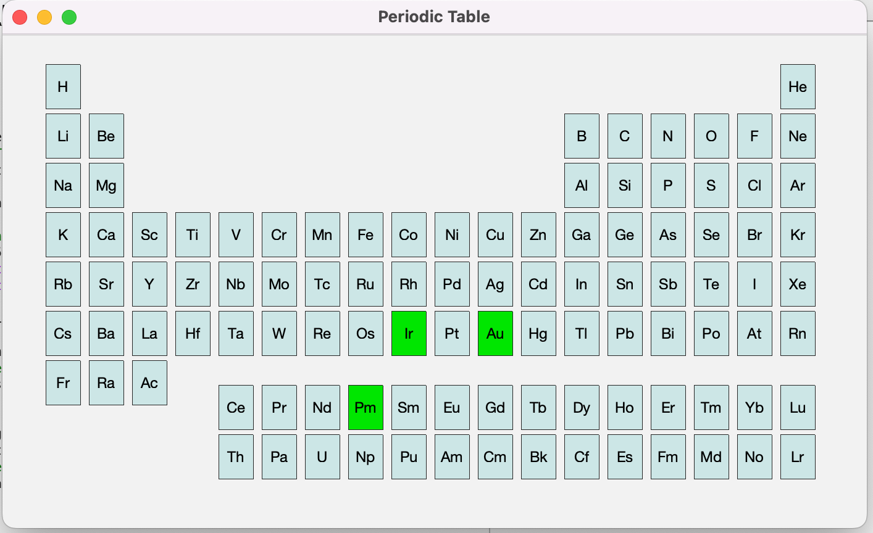

In the command window:

